Assignment-IV

|  |  |
| --- | --- |
| Name | Aswin Venkat R |
| Team ID | PNT2022TMID14584 |
| Roll No | 7179KCTKCTKCTKCTKCTKCTKCT19BCS013 |
| Project Name | Customer Care Registry |

1. Pull an Image from docker hub and run it in docker playground.

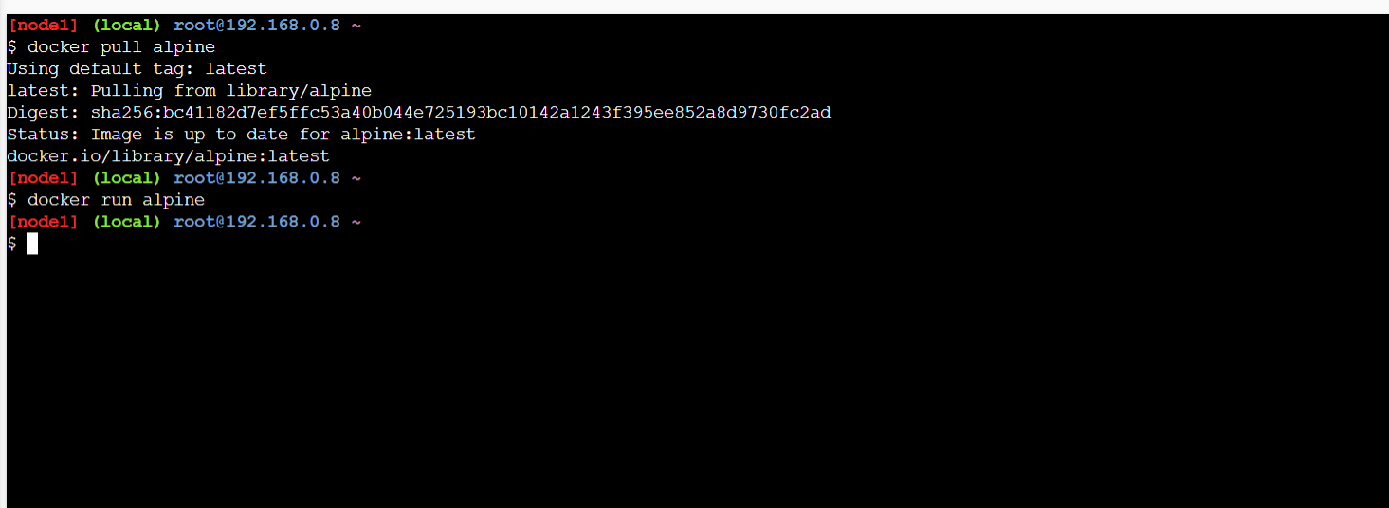

2. Create a docker file for the hello world application and deploy it in Docker desktop application.

Building the image from the file: docker build -t helloworld:0.1 .

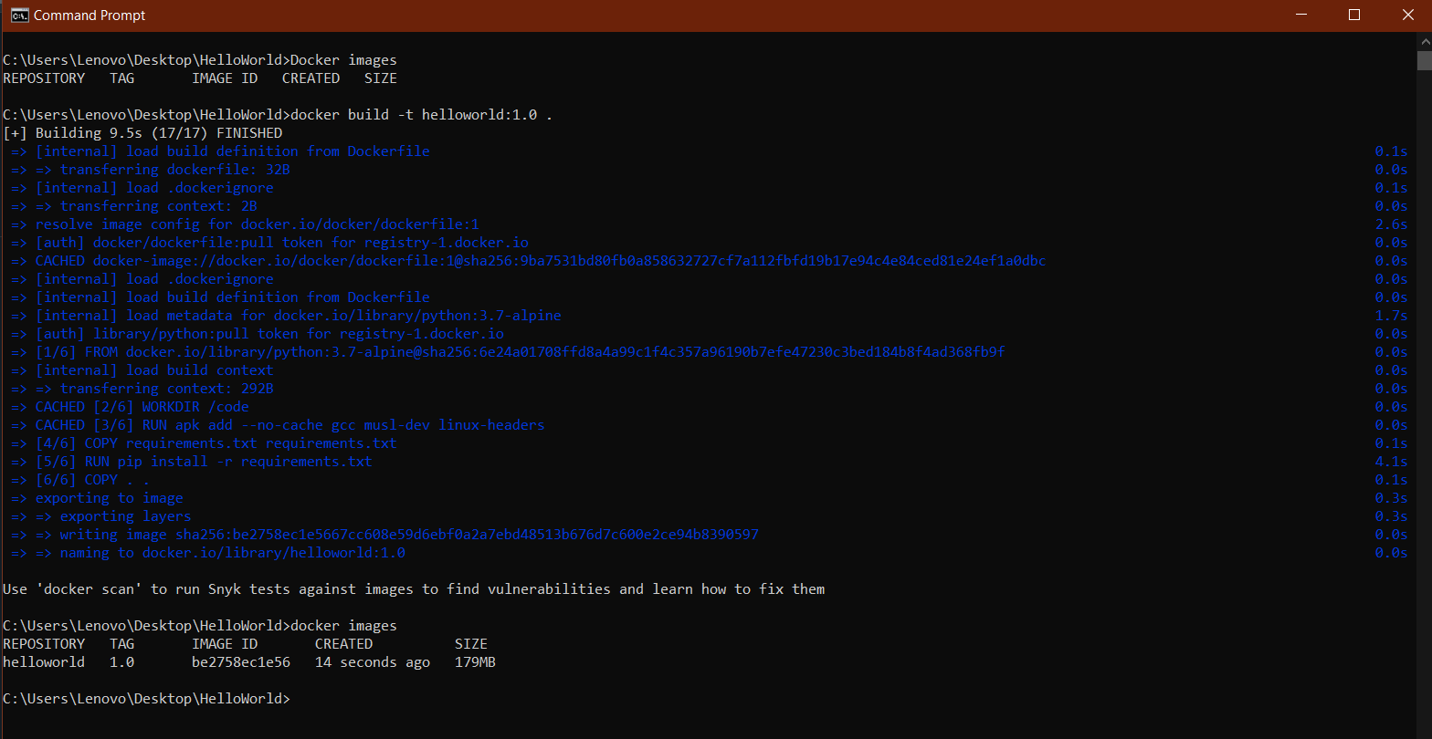

Docker desktop app:

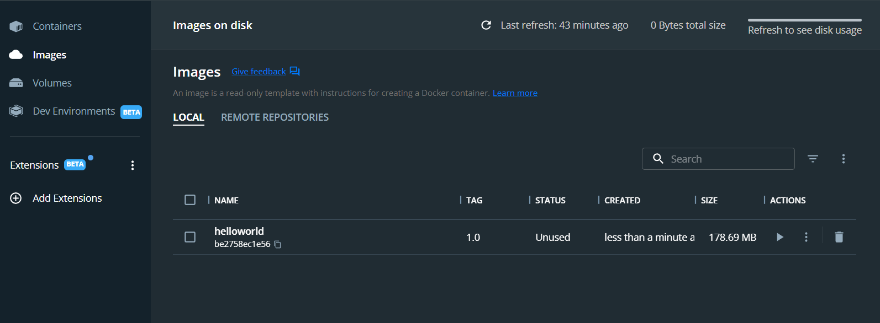

Run the container:

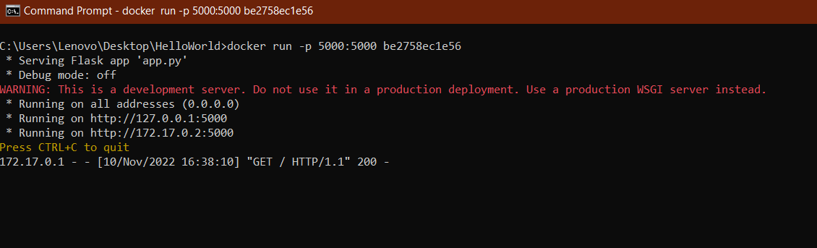

Output:

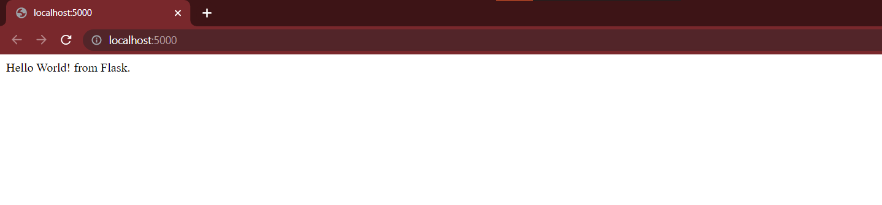

3. Create a IBM container registry and deploy helloworld app.

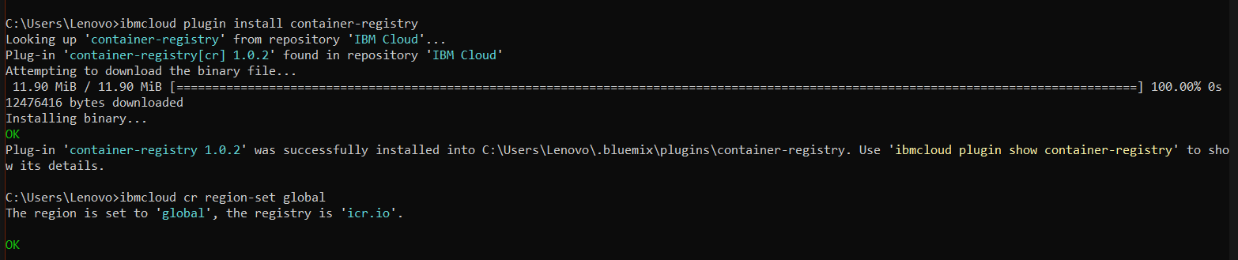

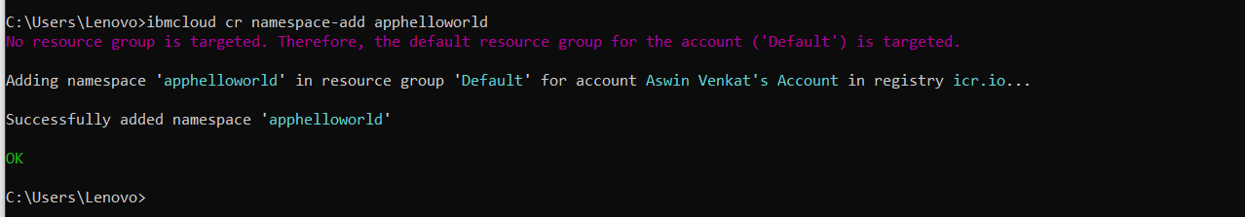

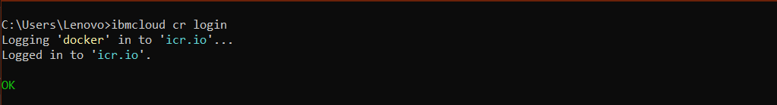

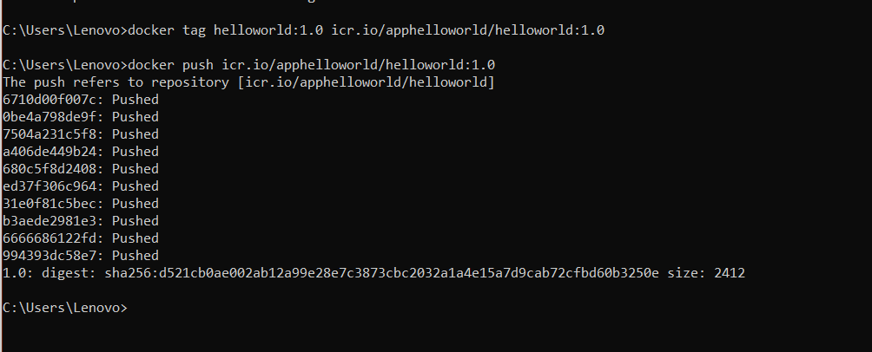

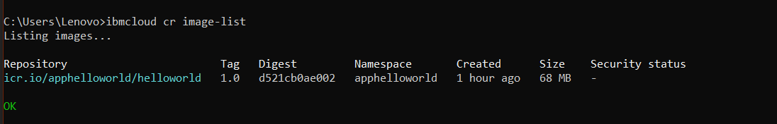

The image is pushed to the namespace.

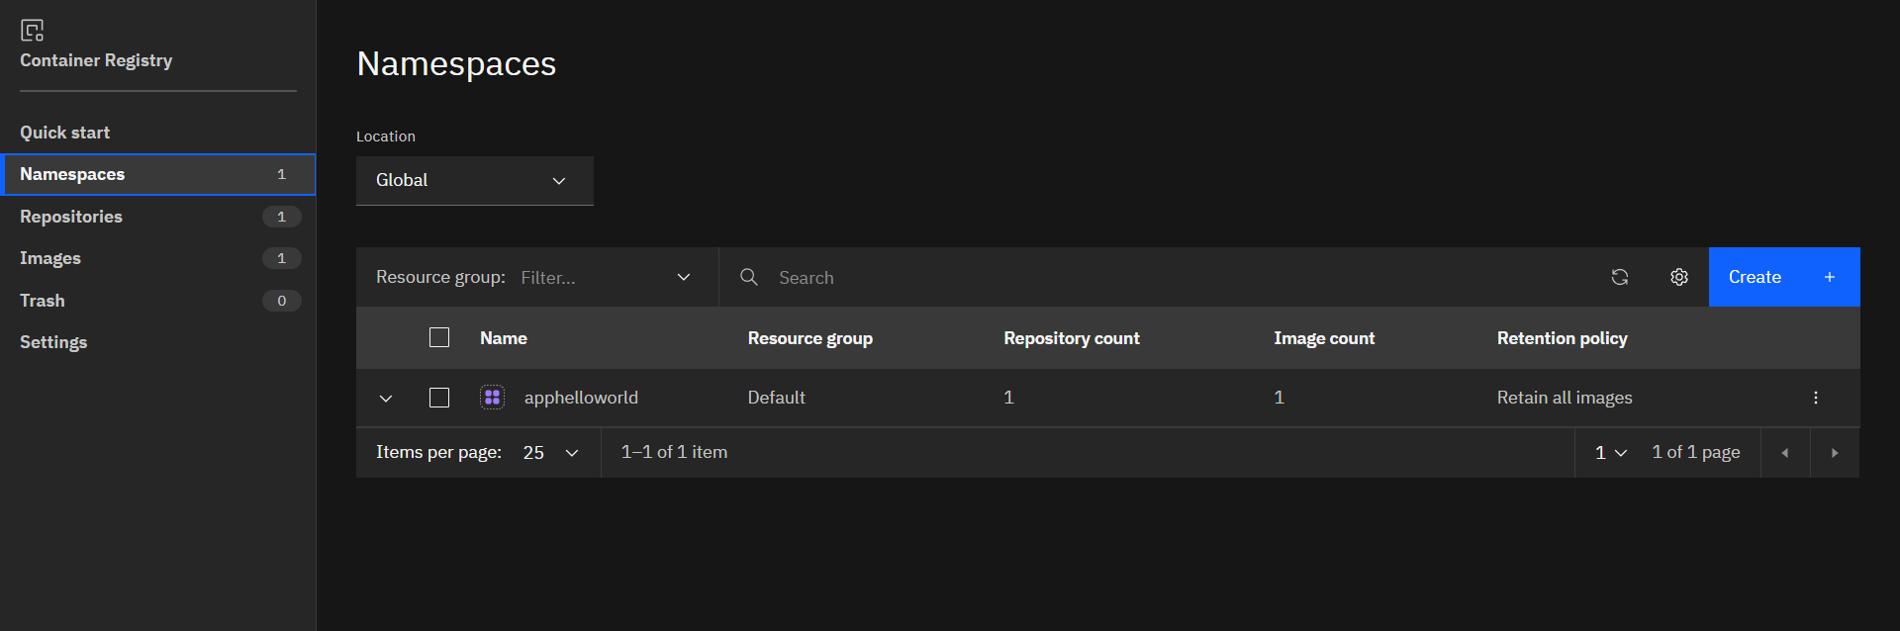

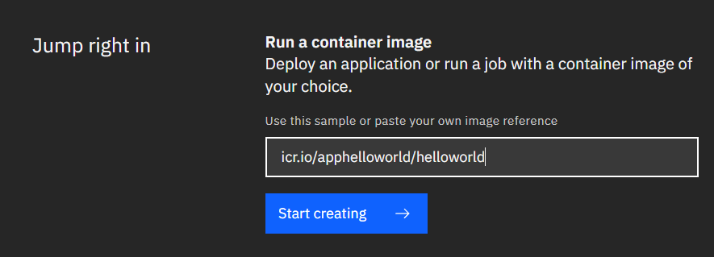

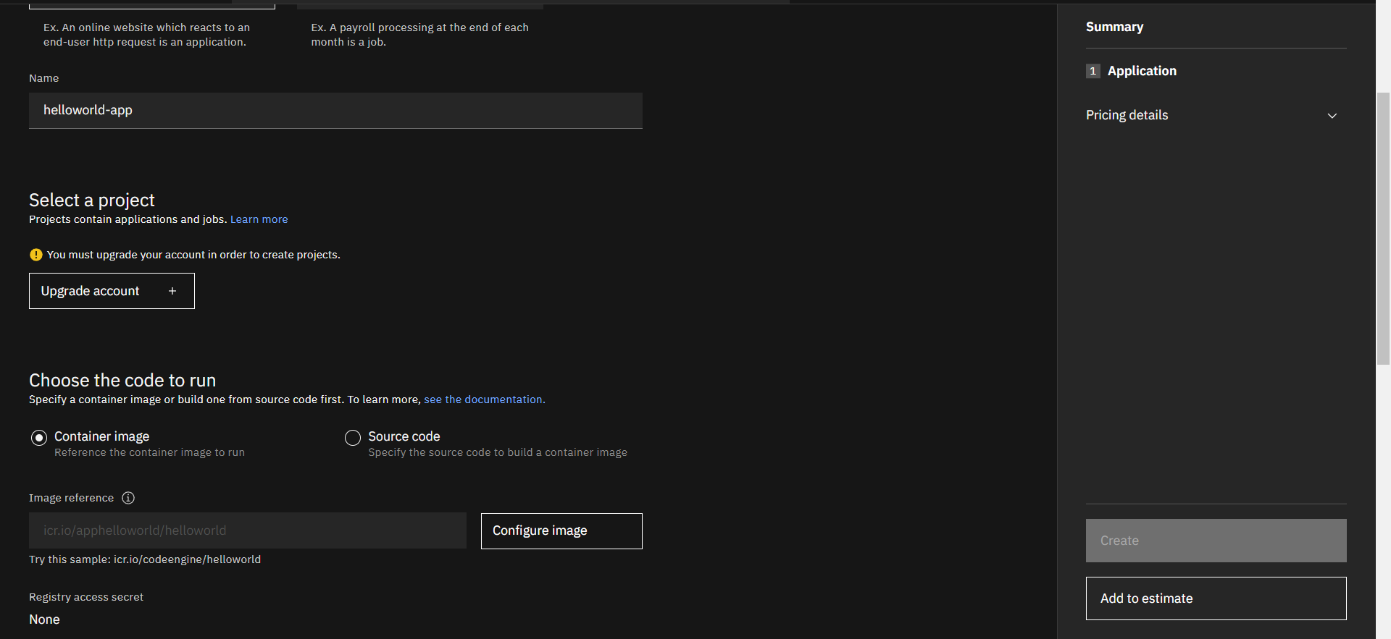

4. Create a Kubernetes cluster in IBM cloud and deploy helloworld image and also expose the same app to run in nodeport.

Cluster:

